Assignment 4
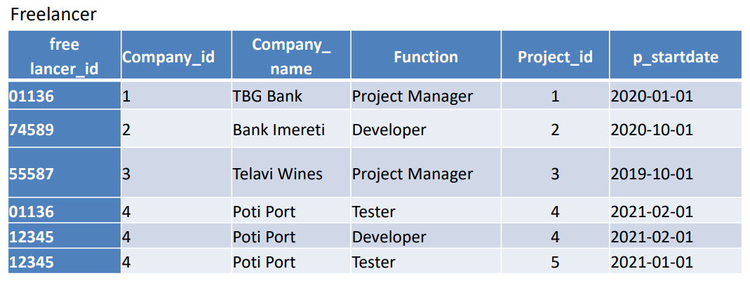
- The key of this relation would be freelander_id and project_id.
- {company_id} -> {company_name}
{freelancer_id, project_id} -> {function, p_startdate}
{project_id} -> {company_id, p_startdate}
- The relation is in 2nd Normal Form because all non-prime attributes are fully dependent on the primary key
- To transform the relation into 3rd Normal Form we can create three tables like this:
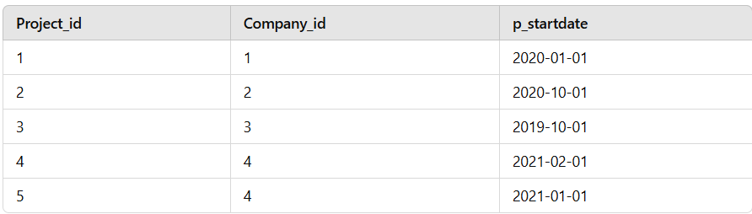
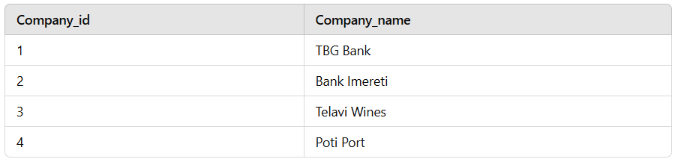
- A) The only dependencies are on the candidate key and there are no partial or transitive dependencies.
B) we do have a dependency : {project_id} -> {company_id, p_startdate}, where project_id is a candidate key.
C) another dependency is {company_id} -> {company_name}, where company_id is a candidate key.

